Technical Review Paper:
Data Transmission With Infrared Modulation

James S. Liu
ECE 2031, Digital Design Lab
Section L10

Georgia Institute of Technology
School of Electrical and Computer Engineering

Submitted
October 7, 2013

Introduction
This paper’s purpose is to review the basic principles and the common techniques of infrared modulation for the purposes of digital communication. Infrared light is electromagnetic radiation with frequencies lower than visible red light but higher than microwaves. Modulation is defined as modifying properties of a periodic waveform, the carrier waveform, with another signal, the modulating signal, to transfer data. Primarily used in remote control systems, infrared modulation allows for short distance, wireless, low power, and low rate data transmission ^{[1]}.

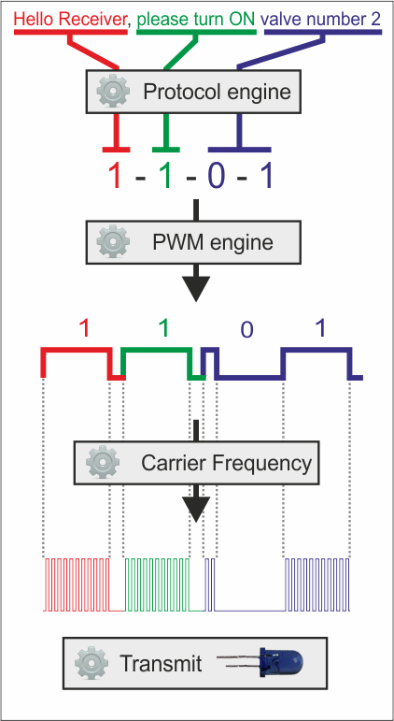
Description of IR Modulation
Infrared Light as a Carrier Waveform
Systems that use IR modulation use infrared light as a carrier wave as infrared light by itself cannot be used to transmit data, as its frequency is too high to properly transmit data. It is instead modulated, by actively turning on and off the IR light source, to a frequency that is easier to detect (36-56 KHz) ^{[1]}. This modulated signal is detectable but does is not capable of transferring data by itself and must be modulated once more to create a coherent signal for data transfer, as shown in Figure 1.

Amplitude Shift Key Modulation
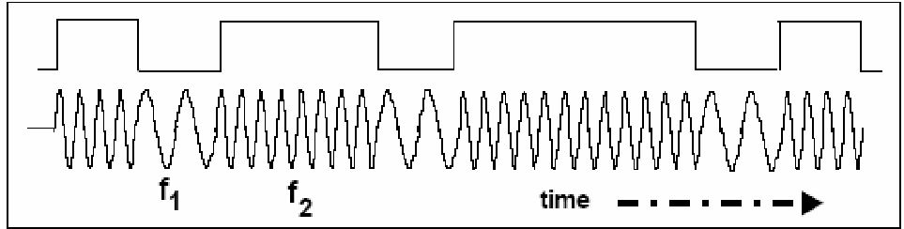
All three techniques of IR modulation reviewed by this paper: pulse length, pulse distance, and bi-phase, belong to a subset of IR modulation known as amplitude shift key modulation (ASK). ASK transmitters modulate the amplitude. Frequency is kept constant. Bits are represented as bursts of IR light or lack thereof. This contrasts FSK, or frequency shift key modulation, where amplitude is constant and frequency is modulated. Bits in FSK are represented rather as sections of high or low frequency ^{[2]}.
Figure 1. The process of modulating an infrared waveform with a digital signal ^{[4]}.
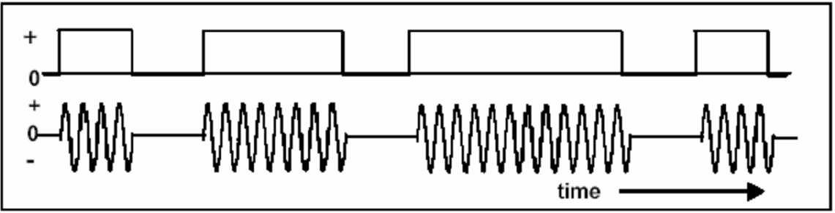
Figure 2. Amplitude shift key modulation ^{[2]}.
Figure 3. Frequency shift key modulation ^{[2]}.

Common IR Modulation Techniques

Pulse Length Modulation
Pulse length modulation represents each bit as the length of each IR light burst: “1” is a long burst of IR light and “0” is a short burst. Each burst of IR light, regardless of value, is separated from preceding and following bits by a fixed length quiet period ^{[1]}.
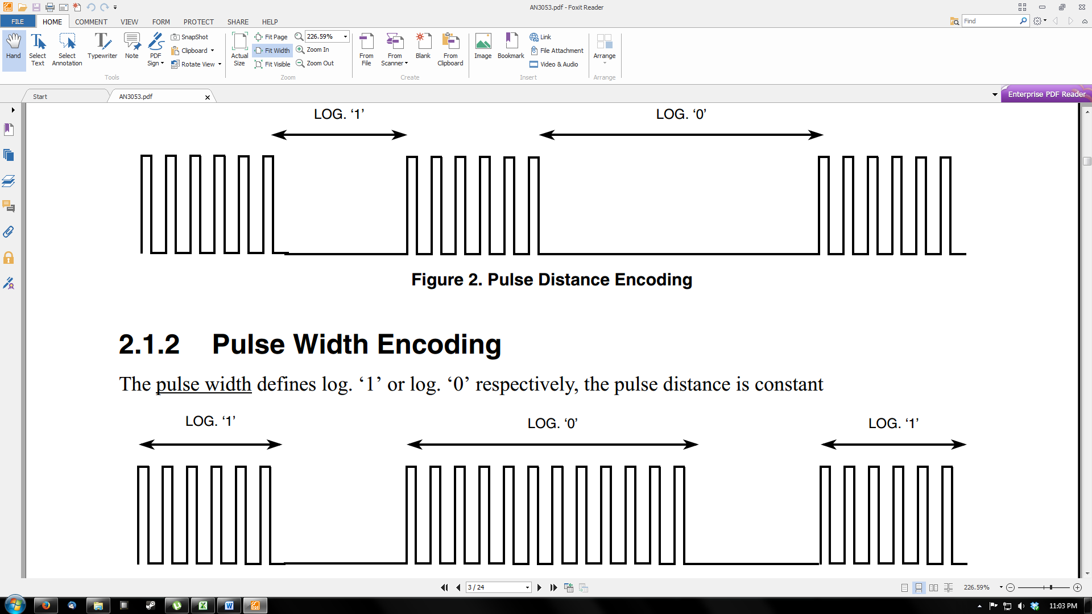
Figure 4. General scheme of pulse length modulation. Burst length represents bit value^{[3]}.

Pulse Distance Modulation
Pulse distance modulation represents each bit as the length of time between fixed length bursts of IR light ^{[1]}.
Figure 5. General scheme of pulse distance modulation. Bits are represented by the distance between bursts ^{[3]}.

Bi-Phase Modulation

Bi-phase modulation divides the signal into continuous bit periods of fixed length with each slot representing its respective bit as a rising (1) or falling (0) edge in its center. Every IR light burst sent constitutes either the first or second half of a bit period and is always half the length of a bit period ^{[1]}.
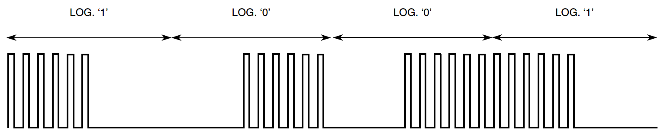
Figure 6. General scheme of bi-phase modulation. The change in IR light halfway through time slots represents bit value ^{[3]}.

RC 5 Standard
The RC 5 standard uses bi-phase modulation with a 36kHz carrier frequency. Each word sent consists of two start bits followed by a toggle bit, five address bits, and six command bits, in listed order. The start bits mark the start of a new word. The toggle bit is toggled with each controller key press. The five address bits represent the controlled device’s address. The six command bits transmit the control information to the target device. Each bit consists of a half bit period of 32 pulses of IR light and half a bit period without transmission ^{[1]}.

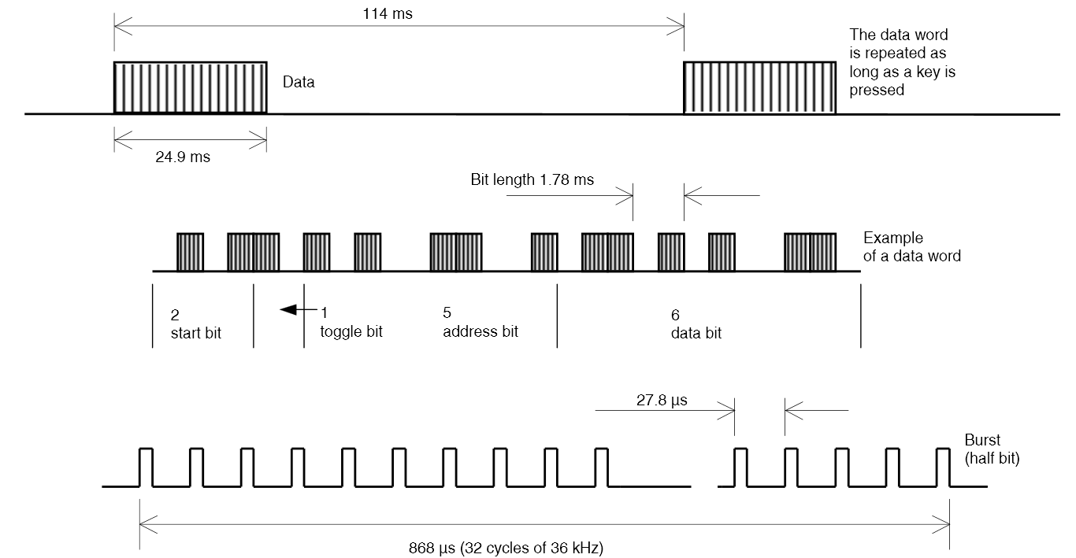

Figure 7. RC 5 Standard specifications.

NEC Code

The NEC (National Electric Code) Infrared Transmission Protocol uses pulse distance modulation with a carrier frequency of 38kHz. Each word sent is started by a 9ms burst called the leader code followed by a 4.5ms pause and the 8 bit address and 8 bit command. Both the address and command are sent twice, once normally then once with the data bits inverted. This redundancy is to verify the received message and to ensure that transmission time is constant. Only one command is sent per control button press. Instead, repeat codes are sent every 110ms constituting of the leader code and a single 560µs burst, unlike RC 5 which repeats the same command message until the button is released ^{[5]}.

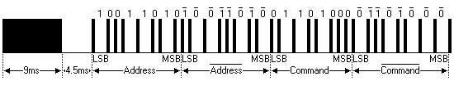

Figure 8. Example NEC data word. Note the repeated address and command bits ^{[5]}.
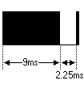
Figure 9. NEC Repeat code ^{[5]}.

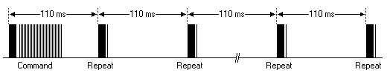

Figure 10. Example NEC repeat pattern ^{[5]}.

Works Cited
- "Data Formats for IR Remote Control," Vishay Semiconductors, Doc. 80071, Aug. 12, 2013. Available: http://www.vishay.com/docs/80071/dataform.pdf
- R. Kumaresan. (2012, Sep). Amplitude Shift Keying & Frequency Shift Keying. University of Rhode Island. Kingston, Rhode Island. [Online]. Available: http://www.ele.uri.edu/Courses/ele436/labs/ASKnFSK.pdf
- P. Lajšner. (2008 Mar). Infrared Remote Control Techniques on MC9S08RC/RD/RE/RG Family. Freescale Semiconductor. Czech Republic. [Online]. Available: http://www.freescale.com/files/microcontrollers/doc/app_note/AN3053.pdf
- G. Lazaridis. (2012 Jul 30). Remote Control Basics - Understanding Protocol and Modulation. PCBHeaven. [Online]. Available: http://www.pcbheaven.com/userpages/RC_Protocol_and_Modulation/
- S. Bregmans. (2013 Jan). NEC Protocol. Netherlands. [Online]. Available: http://www.sbprojects.com/knowledge/ir/nec.php

